Information Sheet for Shooting Scenes
By William Lulow

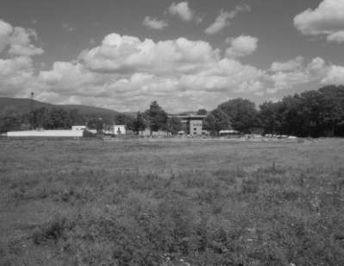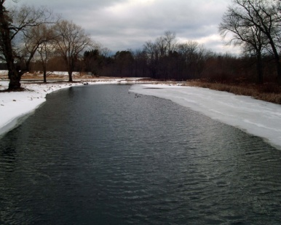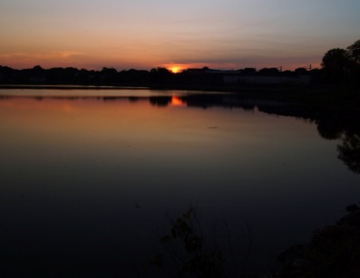
- Decide on a point-of-view
- Decide what you want to show
- Pick a good time of day
- Use a tripod whenever possible
- Try to show foreground in wide-angle shots as close as possible

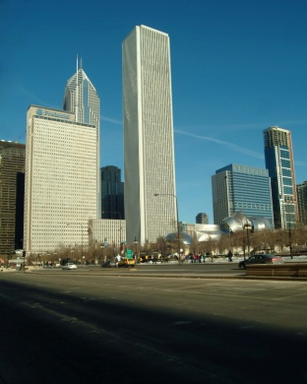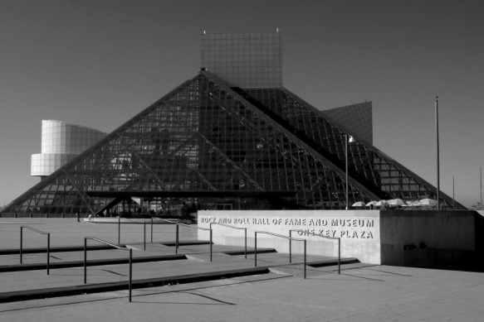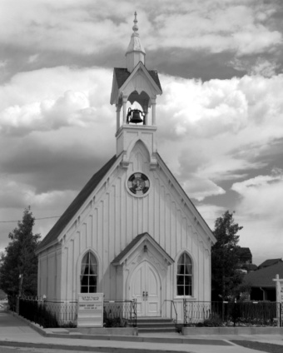

When shooting architecture or single structures:
- Pick a good vantage point
- Use a slightly longer lens if you can to reduce distortion
- Try to use a filter to heighten contrast
- Beat the sunrise, wait past sundown
  - Warmer colors, excellent light within two hours of sunset/sunrise
  - Often displays extraordinary clouds
  - Side lighting improves textures, lengthens shadows for dramatic look
  - Ground fog/mist provides interest and creates mood early a.m.
- Setting – Scout Your Location
  - Practice someplace close to home and revisit often at different times of the year
  - Make a written or visual journal of favorite shooting locations
    - Take pictures each time you are there regardless of…
      - Bad light, poor conditions, not having the right gear
    - Even a few written notes will help for next time
- Setting – Scout Your Location
  - For cityscapes try Google search under Images using the city name
  - Find great tips in general Landscape/Nature photography books
  - For traveling outside the U.S. brush up on the culture, history, architecture and customs of your destination
- Take a tripod whenever possible.
  - Lightweight tripod is better than none.
- Consider a polarizing filter, if your camera allows
  - Improved color, color saturation, less reflections
- Consider custom white balance
  - May dramatically improve color accuracy
  - Reduces post processing in home computer or at photo lab
- Cityscapes and Low Light Shooting
  - For night shots in the city and elsewhere, try your camera’s night mode, if available
    - Flashes for subject in foreground (within 10ft.), and uses a slower shutter speed to let in the ambient light in the background.
    - Tripod or other method of steadying the camera will be a must.
  - Use the self timer for sharper pictures
- Whether using DSLR or P&S camera with zoom range, try wide angle and telephoto
  - Wide angle establishes a scene, has different impact than telephoto
  - Telephoto is handy for isolating parts of a scene
    - Helps simplify if many distracting elements exist
    - Creates variety, encourages exploring new ideas
- Plan composition with camera before setting up the tripod
  - Free yourself up by selecting camera position handheld first
- Seek out objects to convey scale
  - People, animals, solitary trees, tree stumps, boats, etc.
  - Offers a more three-dimensional look to the scene
- Since horizontal compositions are most common, always try a vertical first, then shoot a horizontal
- Keep the shot interesting by keeping subjects away from the middle of your scene.
- Visualize a grid with horizontal and vertical lines breaking up the scene into 3 sections.
- Build the Scene – Fore, Mid, Background
  - Sometimes great scenic pictures present themselves. Often, we can improve the first perspective we see
  - Fore, Middle, Background like characters in a play – Look for connections between them, similar colors, leading lines, patterns, etc.
  - Move yourself and the camera left, right, up, down and check the scene with your camera
- Build the Scene – Foreground
  - Choosing your foreground subject
    - Mirror lines, shapes, colors of mid and background
    - Use middle-toned or slightly bright foreground subject – Our eyes go to brighter objects first
    - Get VERY close to foreground objects when using wide angle
    - Consider low angle to emphasize foreground subject
- Build the Scene – Foreground
  - Show detail in shadowed areas with fill flash
  - Look for natural framing devices like trees and arches
  - Strong color or tone in foreground object will de-emphasize hazy, blah backgrounds
- Build the Scene – Middle Ground
  - Avoid large, uninteresting middle ground that doesn’t connect well with foreground and background
  - Maintain visual interest with leading lines, patterns of color or middle ground objects
  - Getting camera closer to foreground objects will diminish middle ground
- Build the Scene – Background
  - Keep horizon line straight
    - Use any in-camera grid or guides to help
  - Position horizon on top or bottom third, unless using a reflection
  - Generally, the side included more in the scene (top or bottom), should have the most interesting elements (clouds, mountains, breaking waves, etc.)
  - Find dramatic skies or avoid sky if too bright or too dull
- Build the Scene – Background
  - Clouds are often most exciting just after a storm as sun breaks through
  - Exclude extremely bright or dark spots in the background
    - They detract from subject (especially if bright – we notice brightest areas first)
    - They make the camera’s job more difficult – balancing exposure to suit the entire scene
    - Try exposure compensation to control brightness
- Tying it all together – See it your own way
  - After practicing building a scene, follow your instincts
  - Look for compositions out of the ordinary
  - Select a composition that pleases you, not what you think others will like
- Tying it all together – Know what you like
  - Take time to understand what you like about a scene – Ask yourself questions
    - What interests me most about this scene? Is it the color, amazing shapes, a perfectly symmetrical tree, a unique neon sign?
    - What do I want to emphasize?
    - What do I want to minimize?
    - How can I simplify the scene?

Notes

___________________________________________________________________
___________________________________________________________________
___________________________________________________________________
___________________________________________________________________
___________________________________________________________________
___________________________________________________________________
___________________________________________________________________
___________________________________________________________________
___________________________________________________________________

___________________________________________________________________
___________________________________________________________________
___________________________________________________________________
___________________________________________________________________
___________________________________________________________________
___________________________________________________________________
___________________________________________________________________
Workshop Evaluation: (Kindly tear off this page)

1. Name one important thing you learned from this workshop.
___________________________________________________________________
___________________________________________________________________
2. What might you do differently the next time you’re on vacation with your camera?
__________________________________________________________________
__________________________________________________________________
3. Evaluate this workshop. Check off to what degree you found the following helpful (or not). 1 being not very helpful, 5 being extremely helpful.

-Overall presentation________________ 1 2 3 4 5
-Clarity of presentation______________ 1 2 3 4 5
-I understood what the instructor said__ 1 2 3 4 5
-Quality of the illustrations___________ 1 2 3 4 5
-Workshop will help with my images___ 1 2 3 4 5
4. Are you interested in taking more workshops? Yes____ No___ Later____
5. Name and email (optional)
Name: _________________________________________________
Email: _________________________________________________

